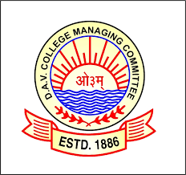

DR. G.L. DUTTA DAV PUBLIC SCHOOL
Transport Nagar, Kankarbagh, Patna-800026
Affiliated to CBSE, New Delhi

Tender Notice

Supply and Installation of Digital Signature (Attendance) Machine at the School premise.
Note:- Submission of quotation by 21/08/2021

