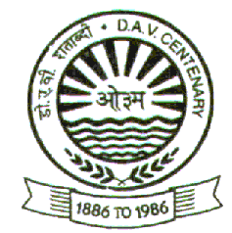DR. G.L DUTTA DAV PUBLIC SCHOOL
Transport Nagar, Kankarbagh, Patna-26

NOTICE FOR THE PARENT’S

This is to notify for all the parents and students that the Results for Half-Yearly/Periodic Examination 2021 will be declared on 9th of October 2021 in between 8 am to 12 Noon.

Parents are requested to come along with their children as per the following schedule:

8 am - 9 am: Roll no. 1 to 10

9 am to - 10 am: Roll no.11 to 20

10 am - 11 am: Roll no. 21 to 30

11am - 12 Noon: Roll no. 31 onwards

Parents are requested to follow all COVID Protocols.
Wearing mask is mandatory.
Please sanitize your hands after entering into the School premise (Automatic Sanitizing Machine is available).

DAV Parivar welcomes all the parent’s

